EXPERIMENT 4: - Create a simple cloud software application for Library book reservation system for SIMATS library using any Cloud Service Provider to demonstrate SaaS include the necessary fields such as Title of the book, author, publications,

Step 1: - Go to ZOHO.com

Step 2: - Create an account and log into the account

Step 3: - Create an application for the respective requirement

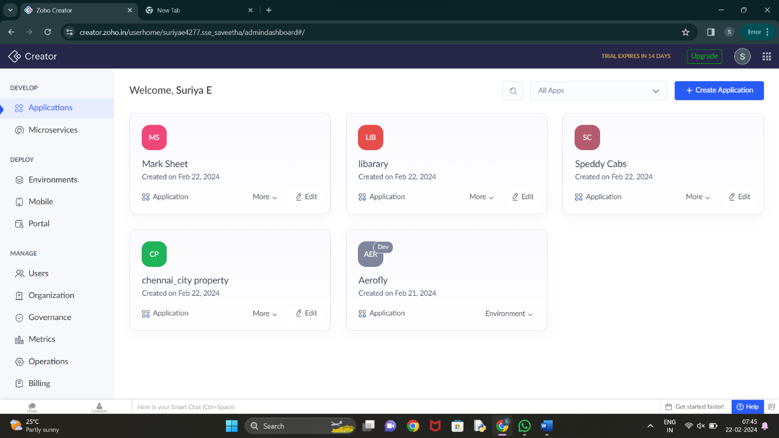

Step 4: - Create the login form for the user or student

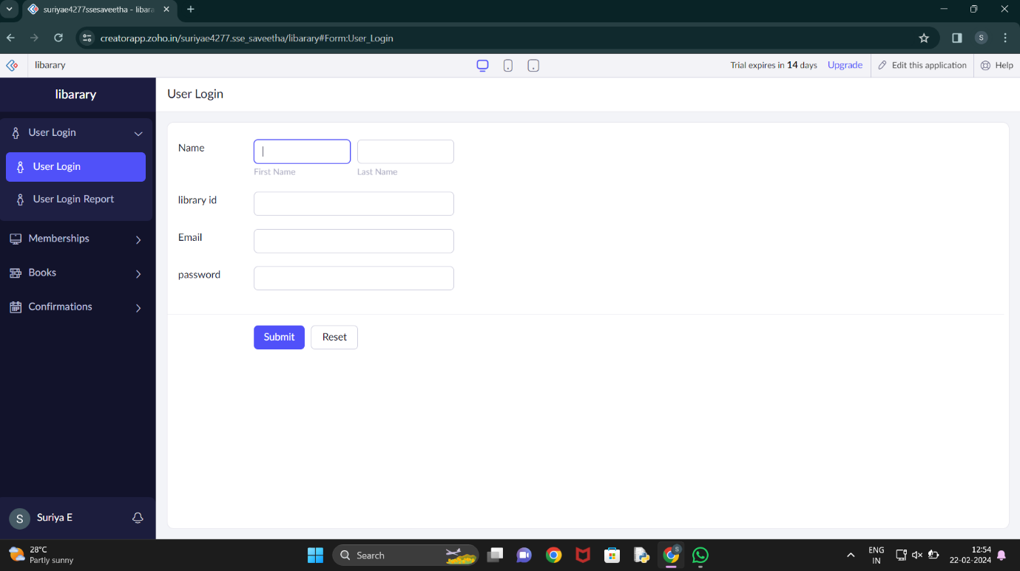

Step 5: - Create membership form for the user’s convenience

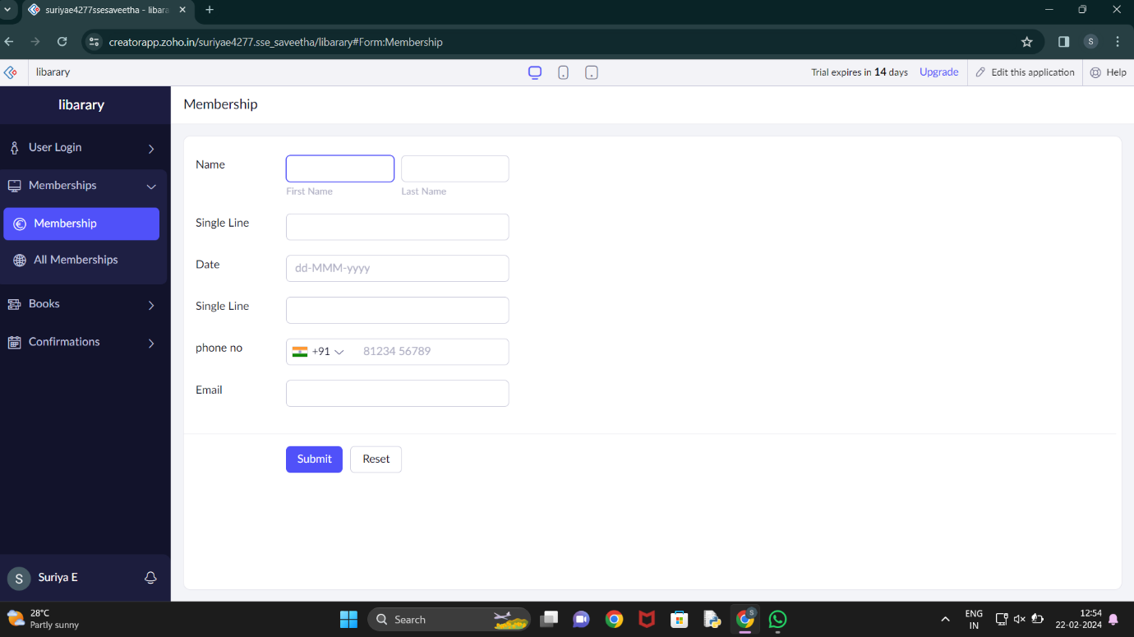

Step 6: - Create next form for book details

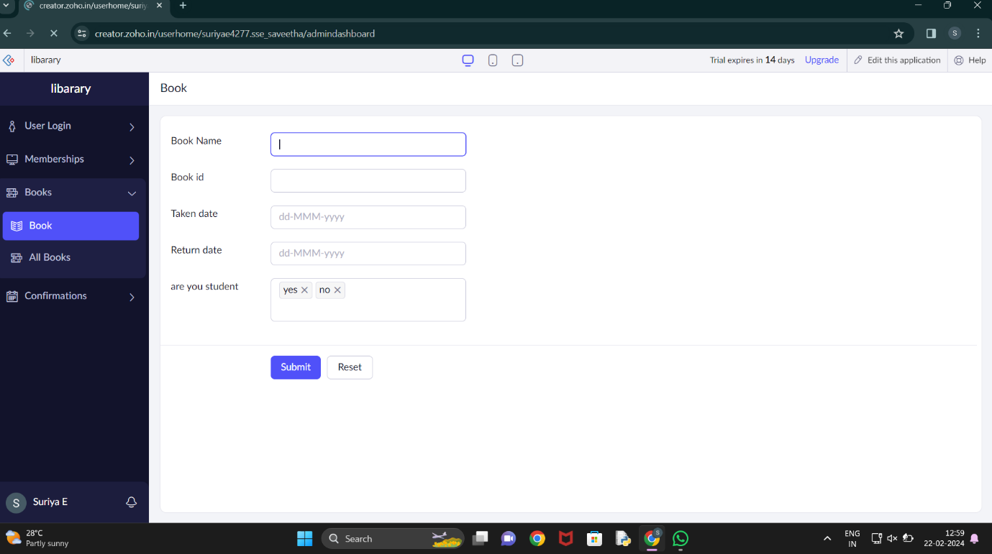

Step 7: - Create a form for confirmation

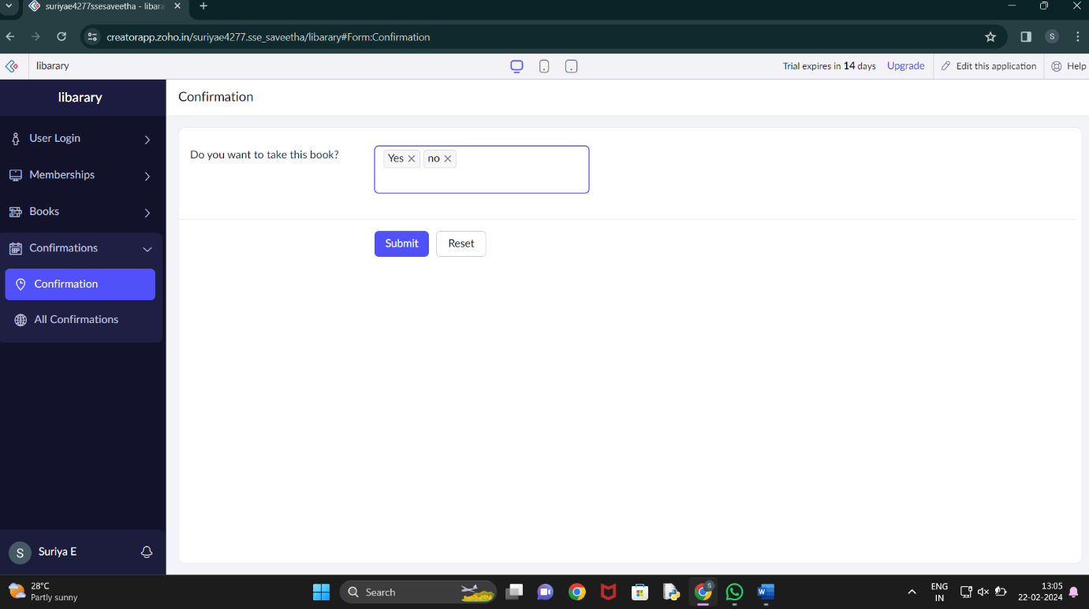

Step 8: - Click the Access development live to view the output

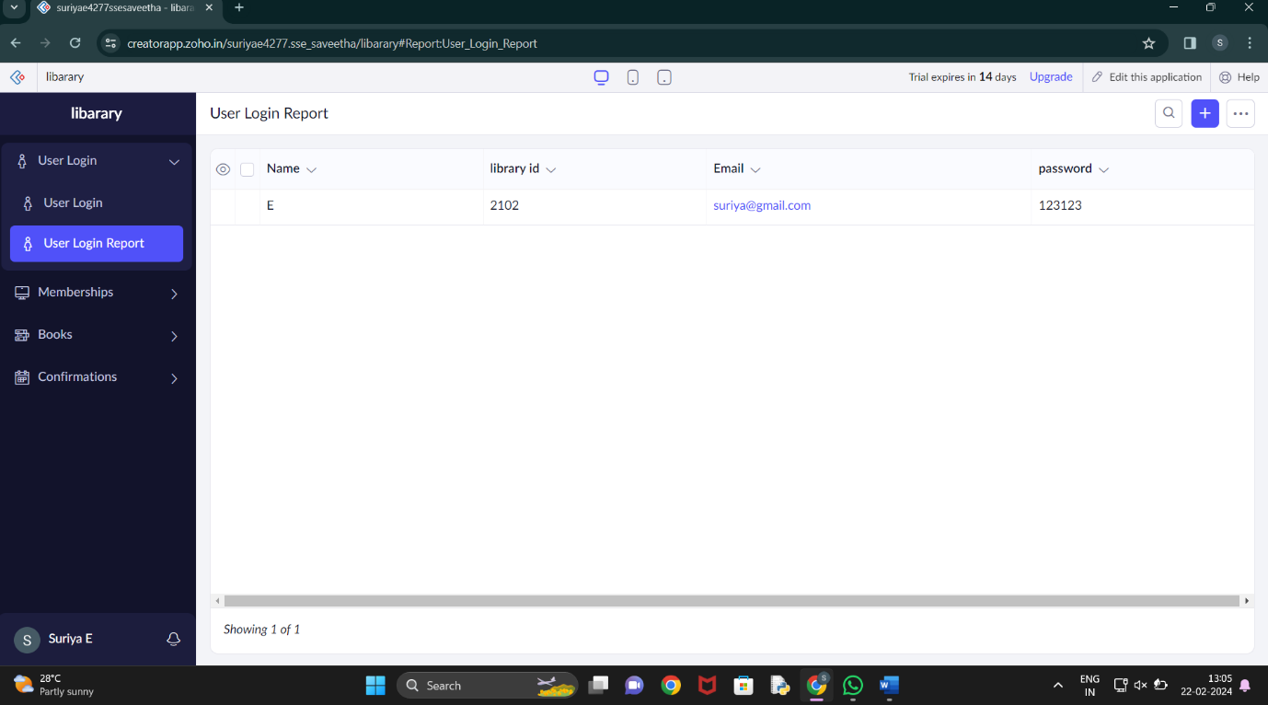

Step 9: - Click the report to view the data added



Step 10: - Click the mobile icon to view the output in mobile format

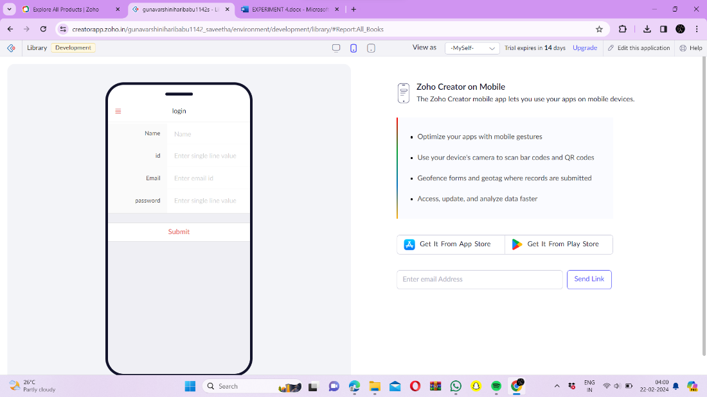

Step 11: - Click the tablet icon to view the output in tablet format

